**What is Formal Communication?**

The communication in which information flows through proper and pre-defined solutions is referred to as Formal Communication. It follows a hierarchical chain that is generally established by the organization itself.  
  
This type of communication is a must in the workplace because employees are expected to follow formal communication while performing their duties. Some general examples of formal communication are reports, commands, orders, etc.

**Types of Formal Communication**

**1. Vertical**

In this type of formal communication, information exchange takes place at different organizational levels. Either the communication takes place from superior authority to subordinate or vice-versa.  
  
It is also classified into two types:

* Bottom-up: Communication flow is from subordinate to superior authority.
* Top-down: Communication flow is from superior authority to subordinate.

**2. Lateral or Horizontal**

This type of communication takes place between two employees of the same level but working in different departments.  
  
For example, communication that takes place between the Sales Manager and Human Resource Manager.

**3. Diagonal or Crosswise**

This type of communication takes place between employees of different departments working at different levels.  
  
For example, communication between Salesman and Manufacturing manager.

**What is Informal Communication?**

Informal communication is multidimensional, it flows freely in the organization without any restraint of predefined channels or routes. It is comparatively very quick and relational.  
  
In organizations it is often called the ‘grapevine’. It is also important for the growth of a company because employees can discuss work-related issues more openly which ultimately saves the company’s time and money.  
  
Some general examples are - chats between team members, a private journal or diary, etc.

**Types of Informal Communication**

**1. Single Strand Chain**

The communication in which one person tells something to another who again says something to another person and the process continues.

**2. Cluster Chain**

In this type of informal communication, one person tells something to some of his friends then they circulate that among their close friends and the process goes on.

**3. Probability Chain**

In this type, one person randomly chooses some persons and transfers information to them and they also do the same later on.

**4. Gossip Chain**

This type of communication is very common in an organization, where a person tells something to a group of people then they also spread it further to another group of people till it gets passed to everyone.

**Key Differences Between Formal and Informal Communication**

1. A set of commands is followed for formal communication whereas informal communication can move freely in all directions.
2. Formal communication is time-consuming, whereas it costs less time for informal communication.
3. Formal communication has its scope restricted within the organization whereas informal communication has no boundary.
4. A high level of secrecy is maintained for formal communication, whereas it’s not guaranteed for informal communication.
5. Formal communication is designed at the organizational level whereas informal communication occurs naturally.
6. Documentary evidence is always available for formal communication whereas there are no supporting documents available for informal communication.
7. Slang words are never used in formal communication while they can be used in informal communication.
8. Formal communication is also known as official communication and informal communication is also known as grapevine communication.
9. Examples of formal communication are - business letters, reports, orders, etc. while examples of informal communication are face-to-face communication, telephonic conversations, etc.
10. Generally, documentation happens for formal communication whereas no documentation happens for informal communication.
11. Formal communication has a long chain of command whereas informal communication is very simple due to its short chain of command.
12. The main motive of formal communication is to fulfill organizational objectives whereas informal communication is intended to meet personal interests and needs.

## Communication Network

A **communication network** refers to the method that employees pass on information to other employees in an organization. Let's take a look at four different types: the wheel network, chain network, circle network, and all-channel network.

#### 1. Vertical Network:

The vertical network is usually between the superior and subordinate and vice versa. It is two-way communication. The immediate feedback is possible in this type of communication network . It is formal network.

#### 2. Circuit Network:

Under this network two persons communicate with each other. Say Mr. ‘A’ sends message to Mr. ‘B’. After receiving message Mr. ‘B’ communicates the feedback message to Mr. ‘A’. So communication takes the form of a circuit. Therefore it is known as circuit network. It is similar to vertical network but in circuit network ‘A’ and ‘B’ are not necessarily superior and subordinates.

#### 3. Chain Network:

This network of communication follows the organisational hierarchy and chain of command. All subordinates receive commands or instructions from their superior. B, C, D and E, F, G are the subordinates to A in the organisational hierarchy and receive commands from ‘A’ which follows the way shown in the diagram.

#### 4. Wheel Network:

ADVERTISEMENTS:

Here all subordinates receive commands from one superior. This is highly centralized type of communication network where each subordinate receives commands or instructions from a single authority or superior ‘A’ and wants the immediate feedback .

#### 5. Star Network:

Under star communication network all members of the group communicate with each other and exchange information. This network is a must for group communication or where teamwork is involved. This network channel of communication is open to all members of the group. The members communicate with each other without hesitation.

The effectiveness of the above networks of communication channels depend upon their users i.e. the managers at all levels, their subordinates and other members of the organisation and above all the seriousness with which all these human resources make use of the facilities provided to them by the organisation to accomplish its objectives.

## 7 types of communication channels

Not every communication channel is made equally. While each one has its own benefits, there are some forms of communication that are naturally richer and allow you to have deeper conversations, and others that make room for productivity-increasing tools. Below, we’ll give you a thorough look at seven strong channels for business communication and how they can best be utilized.

### 1. Face-to-face communication

The richest communication channel around, face-to-face meetings are often hailed as the most effective way for teams to interact. This is because it reduces any misconstrued messages by allowing for body language, facial expressions, and other nonverbal communication. It’s also the best channel for lengthy conversations.

Because of this, speaking face-to-face is an excellent way to get complex or sensitive messages across or brainstorm with a group of co-workers.

This channel can be both formal and informal, depending on the manner in which it occurs. You can have a simple face-to-face conversation from your desk, or schedule a formal meeting in a conference room ahead of time. Be discerning about which one you choose, as [71% of managers](https://hbr.org/2017/07/stop-the-meeting-madness) agree that most meetings are unproductive and inefficient. Formal meetings should come with a structure and purpose that can’t be fulfilled through other channels.

**Example use case:** When you need to develop a complete timeline for launching a product with members of multiple departments

### 2. Video conferencing

The next most effective communication channel around, video conferencing retains your ability to read facial expressions while increasing flexibility. You can have a massive group on a video call from anywhere in the world, helping information flow quickly to anyone who needs it.

While businesses often have to pay to use video conferencing tools at a larger scale, they can be extremely helpful real-time [collaboration tools](https://www.podium.com/article/collaboration-tools/). Video calls enable quick screen sharing and reduce travel time, as team members can hop on just by opening a new tab on their computers.

Similar to face-to-face communication, video conferencing allows for complex or lengthy conversations, though prior scheduling is usually expected.

**Example use case:** When you’re calling an all-hands meeting for a remote team

**Suggested tools:** Whereby, Skype, Google Hangouts

### 3. Phone calls

While video conferences do have more of an impact, they’re not always the most convenient. Even if you’re planning to make an informal video call on your smartphone, minimizing the need for prior scheduling, you can’t depend on the other person to have WiFi or be in a place they can turn on speakerphone.

Phone calls are a great alternative when you need to communicate a sense of urgency and get answers quickly. Calls are a real-time, two-way communication channel that still let you hear tone of voice. Plus, as long as no visuals are needed to convey your message, this channel also allows for lengthy discussion.

**Example use case:** When an employee unexpectedly needs to take a day or two off and you need to go over what tasks urgently need to be delegated.

### 4. Emails

When you need a formal communication channel, but don’t want to waste time with scheduling, email is often the best choice. This type of communication is a great way for you to send formal announcements in a structured manner, especially when sending messages down the chain of command.

Emails are a great replacement for outdated written communication methods, like letters and memos, as they offer more security. This is especially important if you want to forward a sensitive document that you don’t want to leave on someone’s desk. Blind carbon copy also lets you protect the identities of people who are receiving your emails (or prevent a reply all).

By using your [professional email address](https://www.podium.com/article/professional-email-address/) to speak to your team, you can often indicate the importance of a message by flagging a message as urgent. However, with [70% of coworkers](https://www.fastcompany.com/3058066/what-is-an-appropriate-response-time-to-email) happy with responses in a four-hour time frame, don’t expect an immediate response.

**Example use case:** When you need to send onboarding documents and an official welcome message to a group of new hires.

**Suggested tools:** Gmail, Microsoft Outlook

### 5. Text messages

Just as [business text messaging](https://www.podium.com/business-text-messaging/) is preferred by modern customers, your modern employees may consider text messages one of the most convenient channels of communication. With a [98% open rate](https://www.forbes.com/sites/stephanieburns/2019/09/06/9-clever-ways-to-use-text-messaging-in-your-business/#e1209f029514), text messages are a surefire way to get short, informal written messages delivered to employees from anywhere—especially when you need it read fast.

There are two risks when using text messages as a channel for internal communication. First, it can lead to employees being distracted with non-work related conversations. Second, business conversations can easily be sent to the wrong person—we’ve all heard the horror stories—which means secure messages should never be sent through this channel.

Still, this informal communication channel is a great way to quickly get answers or send reminders without being obtrusive or requiring an internet connection. It also allows you to send images, videos, links, and your location quickly from your phone.

**Example use case:** When you’re looking for an employee at a conference away from the office

### 6. Online messaging platforms

Online messaging platforms that are specifically built to connect internal teams have risen in popularity in the past few years. This unique communication channel functions much like text messaging, as it provides real-time written conversation, but add a level of professionalism to your informal communication. This is because these platforms are secure, and conversations can easily be limited to select individuals as needed. This channel also allows for more complexity than a text.

Tools like [Podium Teamchat](https://www.podium.com/teamchat/) expand the files you can share beyond pictures and videos. You can also easily forward documents and know they’re getting to the right place. Teamchat even lets you share customer conversations and reviews to assign them out or collaborate on a response.

As an added plus, group messages on Podium Teamchat won’t cause a nuisance since you can easily set your preferences so they work for you.

**Example use case:** When you want to get an instant second opinion from your direct reports on a flyer you designed

**Suggested tools:** Podium Teamchat, Slack

### 7. Social media

Social media is a newer communication channel that businesses are just starting to employ for internal teams. While social media is typically known as a channel for connecting with people outside the workplace, LinkedIn Groups and Facebook Groups present new opportunities for businesses to boost team communications.

Social media groups are great for encouraging internal networking and building culture through less formal business communication. While you can’t reach everyone unless you require social media accounts, these groups can be great for sending reminders about pre-existing announcements or finding a quick helping hand. Notifications are built-in so you can reach the masses in one fell swoop.

## The importance of nonverbal communication

Your nonverbal communication cues—the way you listen, look, move, and react—tell the person you’re communicating with whether or not you care, if you’re being truthful, and how well you’re listening. When your nonverbal signals match up with the words you’re saying, they increase trust, clarity, and rapport. When they don’t, they can generate tension, mistrust, and confusion.

If you want to become a better communicator, it’s important to become more sensitive not only to the body language and nonverbal cues of others, but also to your own.

#### Nonverbal communication can play five roles:

* **Repetition:** It repeats and often strengthens the message you’re making verbally.
* **Contradiction:** It can contradict the message you’re trying to convey, thus indicating to your listener that you may not be telling the truth.
* **Substitution:** It can substitute for a verbal message. For example, your facial expression often conveys a far more vivid message than words ever can.
* **Complementing:** It may add to or complement your verbal message. As a boss, if you pat an employee on the back in addition to giving praise, it can increase the impact of your message.
* **Accenting:** It may accent or underline a verbal message. Pounding the table, for example, can underline the importance of your message.

Source: The Importance of Effective Communication, Edward G. Wertheim, Ph.D.

## Types of nonverbal communication

The many different types of nonverbal communication or body language include:

**Facial expressions.** The human face is extremely expressive, able to convey countless emotions without saying a word. And unlike some forms of nonverbal communication, facial expressions are universal. The facial expressions for happiness, sadness, anger, surprise, fear, and disgust are the same across cultures.

**Body movement and posture.** Consider how your perceptions of people are affected by the way they sit, walk, stand, or hold their head. The way you move and carry yourself communicates a wealth of information to the world. This type of nonverbal communication includes your posture, bearing, stance, and the subtle movements you make.

**Gestures.** Gestures are woven into the fabric of our daily lives. You may wave, point, beckon, or use your hands when arguing or speaking animatedly, often expressing yourself with gestures without thinking. However, the meaning of some gestures can be very different across cultures. While the “OK” sign made with the hand, for example, usually conveys a positive message in English-speaking countries, it’s considered offensive in countries such as Germany, Russia, and Brazil. So, it’s important to be careful of how you use gestures to avoid misinterpretation.

**Eye contact.** Since the visual sense is dominant for most people, eye contact is an especially important type of nonverbal communication. The way you look at someone can communicate many things, including interest, affection, hostility, or attraction. Eye contact is also important in maintaining the flow of conversation and for gauging the other person’s interest and response.

**Touch.** We communicate a great deal through touch. Think about the very different messages given by a weak handshake, a warm bear hug, a patronizing pat on the head, or a controlling grip on the arm, for example.

**Space.** Have you ever felt uncomfortable during a conversation because the other person was standing too close and invading your space? We all have a need for physical space, although that need differs depending on the culture, the situation, and the closeness of the relationship. You can use physical space to communicate many different nonverbal messages, including signals of intimacy and affection, aggression or dominance.

**Voice.** It’s not just what you say, it’s **how** you say it. When you speak, other people “read” your voice in addition to listening to your words. Things they pay attention to include your timing and pace, how loud you speak, your tone and inflection, and sounds that convey understanding, such as “ahh” and “uh-huh.” Think about how your tone of voice can indicate sarcasm, anger, affection, or confidence

## What is cross-cultural communication in the workplace?

According to a recent survey of employees from 90 countries, [89 percent of white-collar workers](https://content.ebulletins.com/hubfs/C1/Culture%20Wizard/LL-2018%20Trends%20in%20Global%20VTs%20Draft%2012%20and%20a%20half.pdf) at least occasionally work in virtual teams, where team members come from all around the world and rely on [online tools for communication](https://pumble.com/learn/communication/best-team-communication-tools/). This means that even the tiniest miscommunication can have major consequences, which is why it is essential to grasp the notion of intercultural communication, with the emphasis on cross-cultural communication in the workplace.

Cross-cultural communication in the workplace deals with understanding different business customs, beliefs, and communication strategies. It occurs when people from different cultural backgrounds communicate with each other. Since we live in the age of globalization, it is only natural that employers are not exclusively confined to hiring people in their close proximity.

As [more and more people are working remotely](https://www.statista.com/statistics/1199110/remote-work-trends-covid-survey-september-december/), there are plenty of opportunities to work for companies from all around the world. When doing so, we should keep in mind that there are [some cultural barriers to effective team communication.](https://pumble.com/learn/communication/communication-barriers/#Cultural_barriers_to_effective_team_communication) Precisely that is why we need a better understanding of cross-cultural communication, and this is when its fundamentals come into play.

### What are the basic elements of cross-cultural communication?

The easiest way to overcome hurdles and avoid misunderstandings in cross-cultural communication is to first get to know [the basic elements of this type of communication](https://www.presencegroup.eu/en/blog/five-fundamentals-effective-cross-cultural-communication). These are: awareness, preparation, language, humor, and openness. Let’s make an effort to become more cross-culturally competent, and find out something about each of these.

#### Awareness

First, we need to be aware that there are differences between cultures. This enables us to communicate with people from different cultures more effectively.

#### Preparation

After we’ve become aware of the cultural differences, we should make an effort to understand the culture of our business partners or coworkers. The failsafe way to achieve that is to research the said culture. So, take some time to read about that country’s rituals and business etiquette. For instance, should you address your international colleagues by their first name or not?

#### Language

Although language plays an important part in intercultural communication, speaking a foreign language fluently doesn’t guarantee that you’re culturally savvy, because native speakers use nuances in speaking that can only be understood if you understand their culture. If, on the other hand, you and your colleagues don’t share a common language, maybe the best solution is to use an interpreter. Just be sure you don’t get lost in translation.

#### Humors

Even though humour is an inseparable part of our communication, when dealing with colleagues from different cultures, we should be careful how we joke around. Sometimes, jokes don’t translate well.

#### Openness

Last but not least, openness is an integral part of communication. Feel free to ask for feedback and admit that you’re nervous.

Now that we’re familiar with the fundamentals of cross-cultural communication, it’s time we illustrate our point with a few examples.

**Formal vs. Informal Presentation Style**

Presentations are a necessary part of business and there will be times when you will be asked to present about a topic.  Sometimes you are given time to prepare a structured presentation and other times you might be asked to give an impromptu presentation with little or no time to prepare.  Each of these presentation styles requires good communication skills but there are unique expectations when delivering a formal vs. and informal presentation. Here is a guide to both.

**Formal Presentations**

A presentation is considered formal when you have been asked to share ideas with an individual or group and you have been given time to prepare.  Formal presentations require a very different approach than presenting to your team during a weekly meeting.

**-Set clearly defined goals.**

In order to deliver a successful formal presentation you need to be very clear about what it is you want your audience to learn.  You need to write down the main points of your presentation and use this as a guide for your outline.

**-Know your audience.**

Are you presenting in front of 100 people or are you presenting in front of a smaller group?  Are you presenting to managers and executives or are you presenting to clients? Are you presenting to people who are familiar with the topic?  You must know your audience so you can tailor your presentation to meet their needs. You might need to include a hand-out for your audience or perhaps an infographic that summarizes your key points.

**-Create an outline.**

When you are giving a formal presentation it is expected that you will be well-prepared and well-rehearsed.  You have been given time to prepare so your audience is expecting a well-structured presentation. Therefore, you need to create an outline of your presentation so you will have an order in which to follow.

**-Use visuals.**

Again, when you have been given time to prepare it is expected that you will have some visuals for your audience.  Formal presentations usually include a PowerPoint or slideshow of some sort so your audience can follow along.

**-Include questions for audience interaction.**

A formal presentation should engage the audience.  You can end a formal presentation with a Q&A session or you can ask questions along the way after each point.

**-Dress the part.**

Just as the name implies, a formal presentation requires more formal dress.  Men might wear a suit or tie while women should wear a nice dress or business suit. You should also always stand during a formal presentation.

**Informal Presentations**

It is fairly common for business meetings to include impromptu presentations.  These types of presentations are usually prepared in a short amount of time and do not require the same organizational methods as a formal presentation.

**-Prepare your material.**

Your boss might give you just a few hours to put together an informal presentation but you still need to spend some time jotting down your main points and a few notes about the topic.  While you don’t necessarily need to write a complete outline, you need to have a clear understanding of your main points.

**-Understand the purpose.**

The purpose of formal presentations is to provide information to a group of people with a few questions at the end.  Informal presentations, however, are about providing information, listening to the reaction, and generating a discussion.  It becomes more like a conversation and the audience will be more involved.

**-Keep visual aids to a minimum.**

If you have time to prepare a quick slideshow it certainly wouldn’t hurt, but informal presentations do not require lengthy visuals.  It would even be acceptable to write on a whiteboard during an informal presentation as opposed to creating a formal slideshow.

**-Consider a hand-out.**

Formal presentations usually include a slideshow that audience members can access for reference.  However, since you don’t have as much time to prepare such a formal slideshow, it is usually effective to use a hand-out of some sort in an informal presentation.

**-Interact with your audience.**

Formal presentations are more about the audience listening while informal presentations are more about interacting with the audience.  It is perfectly acceptable to generate discussion throughout an informal presentation and allow the audience to provide input and feedback.

**-You can dress more casually.**

Typically, informal presentations do not require the suit and tie that formal presentations do.  You still want to look professional, but men can ditch the tie and women can wear a more casual dress.  It would also be acceptable to sit or stand during an informal presentation.

## What Is The Report Definition?

A report is a document that presents relevant business information in an organized and understandable format. Each report is aimed at a specific audience and business purpose and it summarizes the performance of different activities based on goals and objectives.

That said, there are various types of reports that can be used for different purposes, rather you want to track the progress of your strategies or stay compliant with financial laws, there is a different report for each task. To help you identify when to use them we will cover the top 10 most common report formats used for businesses today.

## What Are The Different Types Of Reports?

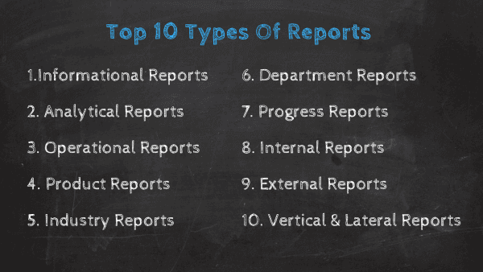

### 1. Informational Reports

The first in our list of reporting types are informational reports. As their name suggests, this report type aims to give factual data about a specific topic. This can include performance reports, expenses reports, justification reports, among others. A differentiating characteristic from these reports is their objectivity, they are only meant to inform but not propose solutions or hypotheses. Common informational reports examples are for performance tracking such as annual, monthly, or [weekly reports](https://www.datapine.com/blog/weekly-report-templates/).

### 2. Analytical Reports

This report type contains a mix of useful information to facilitate the decision-making process through a mix of qualitative and quantitative data as well as real-time and historical data. Unlike informational reports that purely inform users about a topic, this report type also aims to provide recommendations about the next steps and help with problem-solving. With this information in hand, businesses can build strategies based on analytical evidence and not simple intuition. With the use of the right [BI reporting tool](https://www.datapine.com/bi-reporting) businesses can generate analytical reports that include accurate forecasts via predictive analytics technologies. Let's look at it with an analytical report example.

[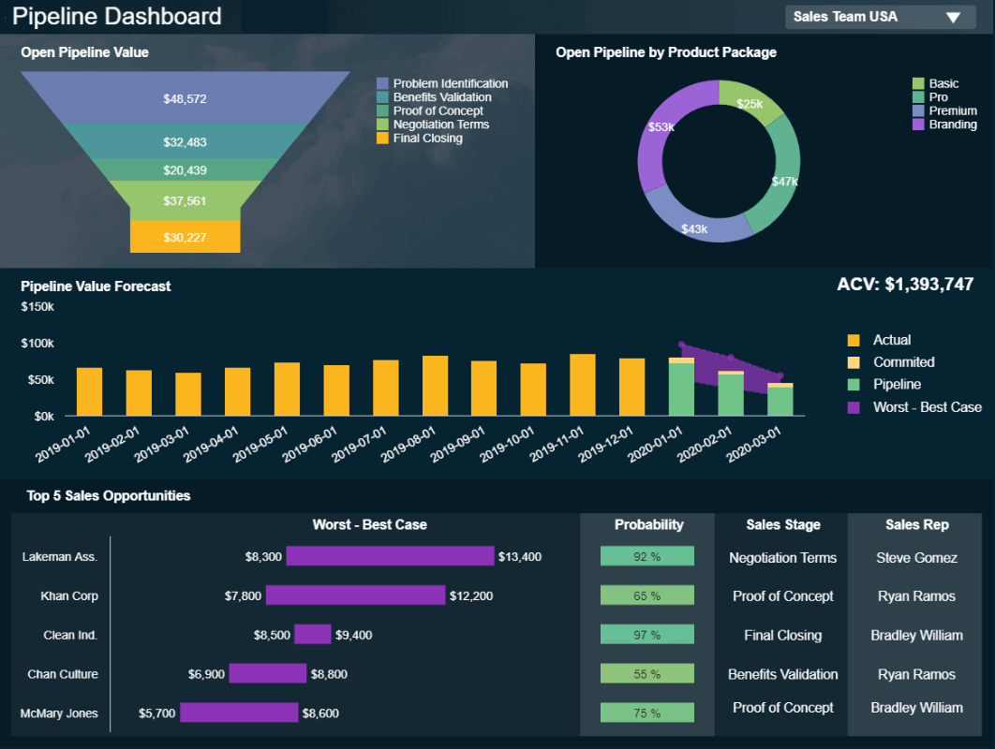](https://www.datapine.com/blog/wp-content/uploads/2022/01/sales-analytical-report.png)

**click to enlarge**

The example above is the perfect representation of how [analytical reports](https://www.datapine.com/blog/analytical-report-example-and-template/) can boost a business’s performance. By getting detailed information such as sales opportunities, a probability rate, as well as an accurate pipeline value forecast based on historical data, sales teams can prepare their strategies in advance, tackle any inefficiencies, and make informed decisions for increased efficiency.

### 3. Operational Reports

These reports track every pertinent detail of the company's operational tasks, such as its production processes. They are typically short-term reports as they aim to paint a picture of the present. Businesses use this type of report to spot any issues and define their solutions, or to identify improvement opportunities to optimize their operational efficiency. [Operational reports](https://www.datapine.com/blog/strategic-operational-reporting/) are commonly used in manufacturing, logistics, and retail as they help keep track of inventory, production, costs, among others.

### 4. Product Reports

As its name suggests, this report type is used to monitor several aspects related to product performance and development. Businesses often use them to track which of their products or subscriptions are selling the most within a given time period, calculate inventories, or see what kind of product the client values the most. Another common use case of these reports is to research the implementation of new products or develop the existing ones. Let’s see it more in detail with a visual example.

[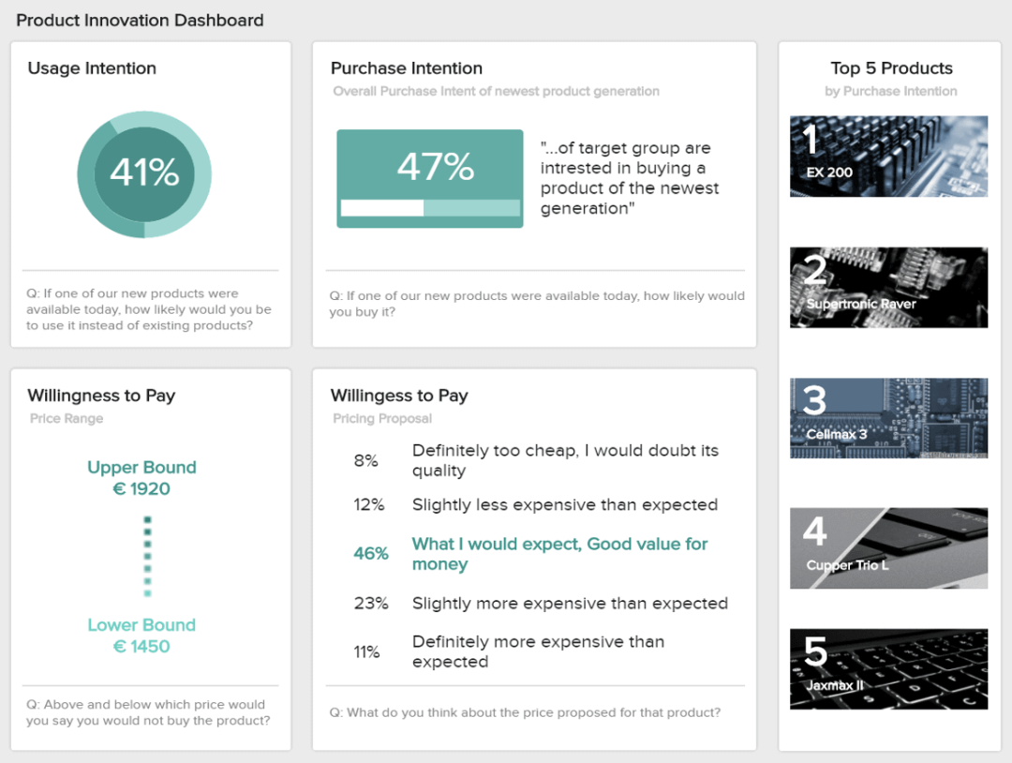](https://www.datapine.com/blog/wp-content/uploads/2018/04/market-research-results-product-innovation.png)

**click to enlarge**

The image above is a product report that shows valuable insights regarding usage intention, purchase intention, willingness to pay, and more. In this case, the report is based on the answers from a survey that aimed to understand how the target customer would receive a new product. Getting this level of insights through this report type is very useful for businesses as it allows them to make smart investments when it comes to new products as well as set realistic pricing based on their client’s willingness to pay.

### 5. Industry Reports

Next in our list of the most common types of reports we have industry-specific reports. Typically, these reports provide an overview of a particular industry, market, or sector with definitions, key trends, leading companies, industry size, among others. They are particularly useful for businesses who want to enter a specific industry and want to learn how competitive it is or for companies who are looking to set performance benchmarks based on average industry values.

### 6. Department Reports

These reports are specific to each department or business function. They serve as a communication tool between managers and team members that need to stay connected and work together for common goals. Rather is the sales department, customer service, logistics, or finances, these specific report type helps track and optimize performance on a deeper level. Let’s look at it with an example of a team performance report.

[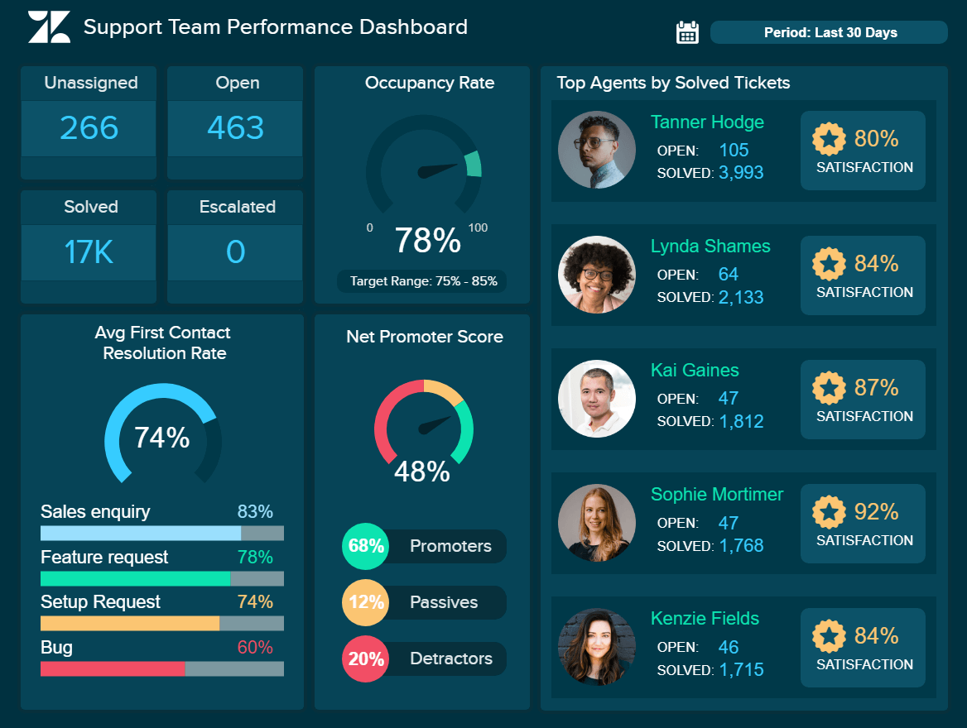](https://www.datapine.com/blog/wp-content/uploads/2019/11/support-team-performance-dashboard.png)

**click to enlarge**

The image above is a department report created with an [online data analysis tool](https://www.datapine.com/data-analysis-tools) and it is tracking the performance of a support team. This insightful report displays relevant metrics such as the top-performing agents, net promoter score, first contact resolution rate, among others. Having this information in hand not only helps each member of the team to keep track of their individual performance but also allows managers to understand who needs more training and who is performing at their best.

### 7. Progress Reports

From the brunch of informational reports, progress reports provide critical information about the status of a project. These reports can be produced on a daily, weekly, or monthly basis by employees or managers to track performance and fine-tune tasks for the better development of the project. Progress reports are often used as visual materials to support meetings and discussions a good example is a [KPI scorecard](https://www.datapine.com/blog/kpi-scorecard-examples-templates-to-track-performance/).

### 8. Internal Reports

A type of report that encompasses many others on this list, internal reports refer to any type of report that is used internally in a company. They convey information between team members and departments to keep communication flowing regarding goals and business objectives.

[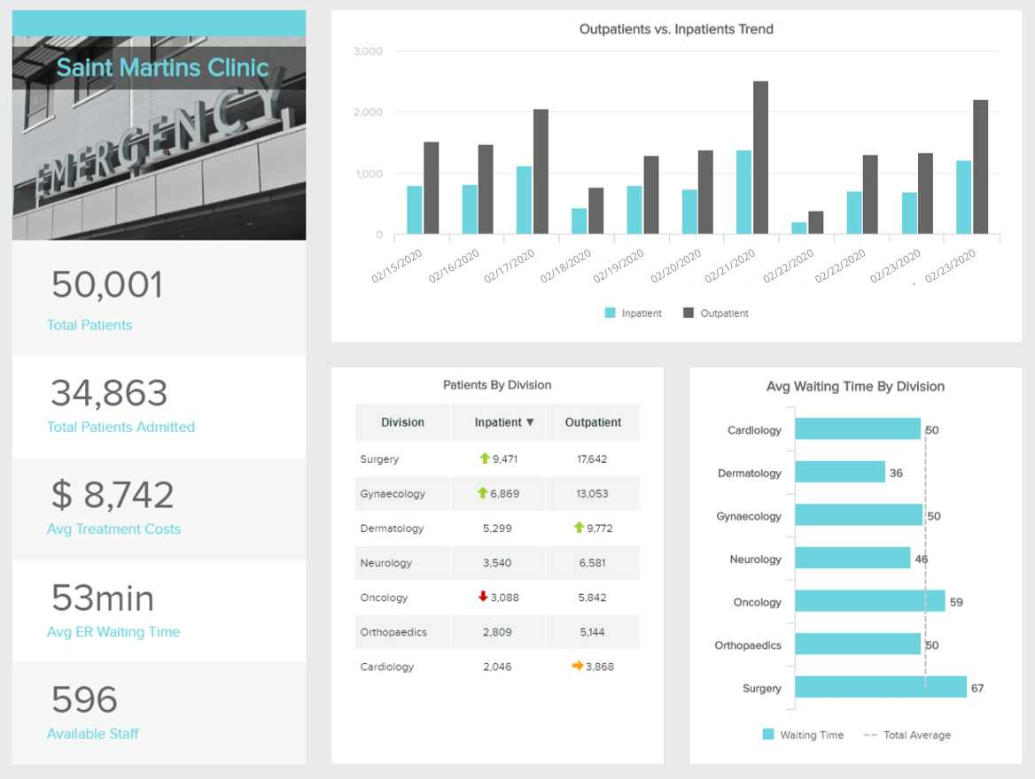](https://www.datapine.com/blog/wp-content/uploads/2020/02/real-time-analytics-example-hospital-kpi-dashboard.jpg)

**click to enlarge**

As mentioned above, internal reports serve as useful communication tools to keep every relevant person in the organization informed and engaged. This [healthcare report](https://www.datapine.com/blog/healthcare-report-benefits-and-examples/) aims to do just that. By providing insights into the performance of different departments and areas of a hospital such as in and outpatients, average waiting times, treatment costs, and more, healthcare managers can allocate resources and plan the schedule accurately as well as monitor any changes or issues in real-time.

### 9. External Reports

Although most of the report types listed here are used for internal purposes, not all reporting is meant to be used in closed doors. External reports are created with the aim of sharing information with external stakeholders such as clients or investors for budget or progress accountability as well as to governmental bodies to stay compliant with the law requirements.

[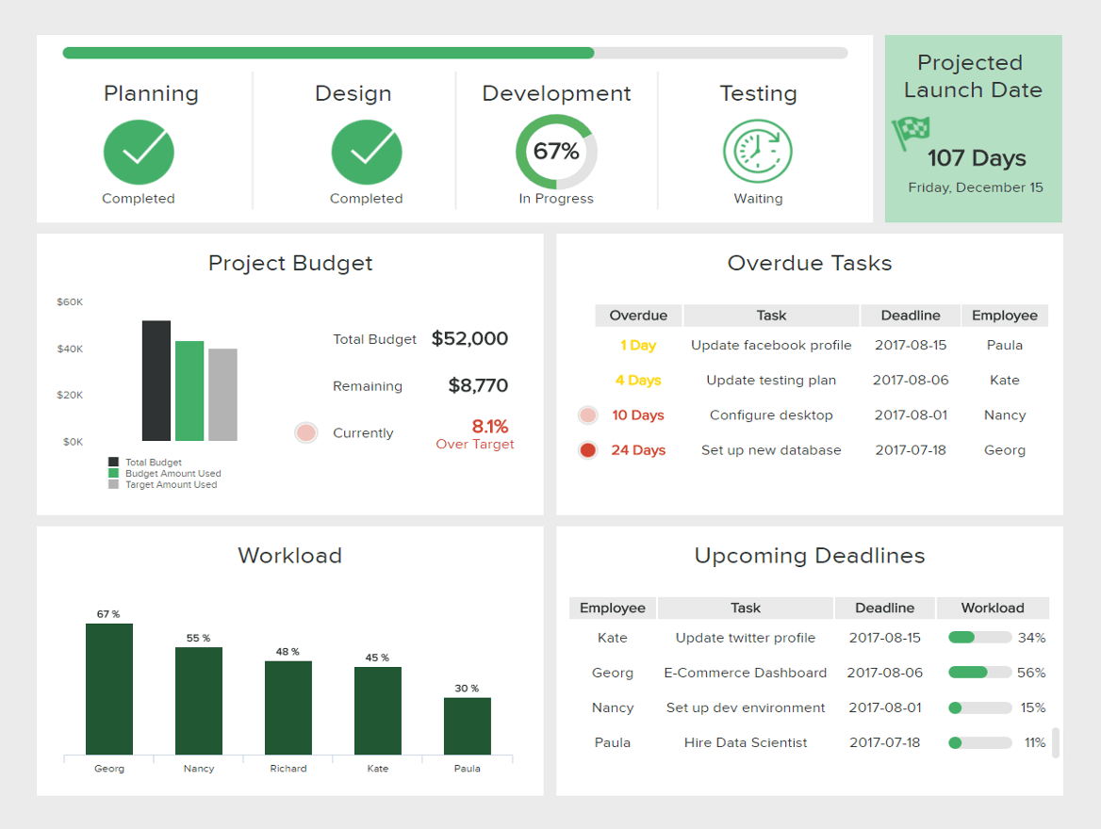](https://www.datapine.com/blog/wp-content/uploads/2018/05/it-project-management-dashboard.png)

**click to enlarge**

The image above is the perfect example of an external [client report](https://www.datapine.com/articles/client-dashboard-report-examples) from an IT project. This insightful report provides a visual overview of every relevant aspect regarding the development of the project. From deadlines, budget usage, completion stage, and tasks breakdown, clients can be fully informed and involved in the project.

### 10. Vertical & Lateral Reports

Last but not least in our rundown of the top 10 types of reports we have vertical and lateral reports. This reporting type refers to the direction in which a report travels. A vertical report is meant to go upward or downward the hierarchy, for example, a management report. While a lateral report assists in organization and communication between groups that are at the same level of the hierarchy, such as the financial and marketing departments.

# The Layout of a Report

### 1. Title page

The title page will vary according to the style required by the assessor or your company. At a minimum, the title page should include:

* Name of the university
* Name of school e.g. School of Mining Engineering
* Name and code of the subject e.g. MINE1740 Mining Legislation
* Title of the report
* Name of author or authors
* Date of submission

Some schools publish styles guides that you are expected to follow when submitting a report. Check with your school office as to whether your school has one.

### 2. Figures and tables

**Figures** include:

* diagrams
* graphs
* sketches
* photographs
* maps

**Tables** represent data in columns.

All figures and tables should be numbered and labelled. Each should have a very simple, descriptive caption explaining the figure or table. Any symbols or abbreviations used in the figure or table must be explained in the text.

The figure must also be referred to in the text, identified by its number, e.g. Figure 23. Avoid using "the figure above" or "the figure below", as text locations may change when editing your report. All figures and tables must be referenced if copied or adapted from another source.

### 3. Equations and formulae

Equations should be numbered as they appear in the text, with a number in brackets on the right hand side margin. This number is used for identification throughout the rest of the text.

Equations are generally centred, with consecutive equations on separate lines and with the equal sign (=) vertically aligned.

y = mx + b (1)

x = l(h + f) (2)

### 4. Chapter numbering system

The numbering of chapters and subheadings is normally undertaken throughout the report. The Introduction is generally numbered 1 with the Reference section having the last number. Third level headings are the generally accepted limit (e.g. 8.4.3); too many levels becomes confusing.

The preliminary sections (i.e. Table of Contents) prior to the Introduction are not numbered. Appendices are usually labelled with letters, e.g. Appendix B.

### 5. Font

Fonts that are easy to read are generally chosen for a report. Times New Roman, Arial and Helvetica are the most popular.

Font size should be a minimum of 12 point for the body text, larger sizes are used for the headings with first level headings being the largest.

The same font should be used throughout the report. It is important not to distract the reader from the contents of the report. Most word processing programs have report templates in them which can be used as a basis for your report style.

### 6. Appendices

Appendices are supplements to a report. They are included as separate sections, usually labelled Appendix A, Appendix B etc., at the back of the report. An appendix includes:

1. information that is incidental to the report;
2. raw data and evidence which supports the report;
3. technical data which is too long and or detailed but which supports the report;
4. maps, folded diagrams, tables of results, letters are some examples.

## How to write a report

Knowing how to write a successful report can make you a valuable asset in your current workplace or an appealing candidate for new employers. Here are some steps to follow when writing a report:

### 1. Decide on terms of reference

Many formal reports include a section that details the document's "terms of reference". These terms include:

* What the report is about
* Why it is necessary
* When it was written
* What its purpose is

Setting these terms helps both the writer and their readers to understand why the report is important and what it hopes to accomplish. The terms of reference are usually explained in the first paragraph so that the reader can determine their relevance without having to read the entire document. Setting concrete terms early on will help you create the report's outline and keep your discussions on track throughout the writing process.

Related: [The Complete Guide to Researching a Company](https://www.indeed.com/career-advice/finding-a-job/the-complete-guide-to-researching-a-company)

### 2. Conduct your research

Most reports will require you to collect a store of data that directly relates to your topic. You may already have access to this information if, for example, you are a doctor who has copies of a patient's medical charts. However, if you are tasked with analyzing an issue or investigating an event, you will likely need to spend some time requesting, finding and organizing data.

Interpreting data and formatting it in a way that your readers will understand is an important part of writing a report. You may need to create charts, graphs or timelines that make your raw information easier to comprehend. You will also need to carefully cite your sources and keep track of where and how you found your data to present it professionally.

Related: [How To Understand Graphs: Types, Uses and Tips](https://www.indeed.com/career-advice/career-development/how-to-explain-a-graph)

### 3. Write an outline

The next step is to construct your report's outline. This typically looks like a bulleted or numbered list of all the different sections in the document. Your report's outline might look similar to this:

* Title page
* Table of contents
* Introduction
* Terms of reference
* Summary of procedure
* Findings
* Analysis
* Conclusion
* References or bibliography

The order of these sections—and whether you decide to include them all—depends on the specific type of report, how long it is and how formal it needs to be. The most important thing to do when writing your outline is to include all the necessary sections and eliminate anything that does not directly contribute to the report's purpose.

Related: [How To Write an Outline](https://www.indeed.com/career-advice/career-development/how-to-write-an-outline)

### 4. Write the first draft

Writing the first draft is one of the most important stages of constructing a successful report. The purpose of the first draft is not to write a perfect document, but rather to get all the main elements of your information out of your head and onto the page. You will have time to add to and edit this first attempt, so your primary goal is just to organize your data and analysis into a rough draft that will eventually become a final product.

While writing your first draft, you will likely find gaps in your data or holes in your analysis. Make note of these, but do not try to address every issue as you write. Instead, finish the draft, and save the problem-solving for when you begin the editing process.

Related: [10 Resume Writing Tips To Help You Land a Job](https://www.indeed.com/career-advice/resumes-cover-letters/10-resume-writing-tips)

### 5. Analyse data and record findings

The focus of every report is the "findings" section or the part where you present your interpretation of the data. For an accountant, the findings could involve an explanation as to why a company's stock drooped during the previous quarter. For an environmental scientist, it could include a summary of an experiment on biodegradable plastics and how the results could affect waste management methods.

The findings section of your report should always provide valuable information related to the topic or issue you are addressing, even if the results are less than ideal. If you conclude that the data was insufficient or the research method was flawed, you will need to explain this professionally and accurately.

### 6. Recommend a course of action

The final section of your report's body is your recommendation. After examining the data and analyzing any outcomes, you are qualified to present an idea as to what actions should be taken in response to your findings. For example, after reviewing the number of overtime hours that their team has been working, a project manager may recommend that an additional employee be added to the team. A surgeon might recommend that the hospital introduce new sterilization methods into the operating room after noting an increase in preventable infections in the previous six months.

If you have presented your data well and shown your expertise, your reader is likely to trust your judgment.

### 7. Edit and distribute

The final stage of writing a report is editing it thoroughly and distributing it to your audience. You will need to edit for grammar mistakes, spelling errors and typing mistakes. You will also need to double-check your data, make sure your citations are correct and read over the entire document to make sure it presents a cohesive narrative. If the report is going to be read by a wide audience, you may decide to ask someone else to proofread it or give you their opinion on the readability of the content.

Distributing the report can take different forms depending on your particular occupation. You might email it to your supervisor, present it verbally during a staff meeting or publish it in a professional journal. Regardless of how or where it is read, your goal is always to create a concise, informative and effective document that will contribute to increased productivity in your workplace.

## Tips for writing successful reports

Here are some final suggestions to guide you when writing reports:

* Know your audience. Before you begin writing, be sure you understand who the report is for, why they need the information and what you want them to do after reading it. Knowing your audience will help you guide your style and ensure you communicate your information as efficiently as possible.
* Proofread carefully. Nothing ruins a quality report quite like a typo. Before you submit or present your report, be sure to proofread it carefully for any errors.
* Be open to feedback. Depending on your job title, you may receive criticism or feedback on your reports. Try to remain receptive and open to critique. If you are willing to take feedback and implement your superiors' suggestions, your writing will likely improve as a result.
* Use your time wisely. Writing a quality report can take anywhere from a couple of hours to several weeks. Before you begin, be sure to budget your time and set a regular writing schedule. You may need also need to set hourly or daily goals to ensure that your progress stays on track.

MEMO:

The format of a memo follows the general guidelines of business writing. A memo is usually a page or two long, single spaced and left justified. Instead of using indentations to show new paragraphs, skip a line between sentences. Business materials should be concise and easy to read. Therefore it is beneficial to use headings and lists to help the reader pinpoint certain information.

**Add Headings:** You can help your reader understand your memo better by using headings for the summary and the discussion segments that follow it. Write headings that are short but clarify the content of the segment. For example, instead of using "Summary" for your heading, try "New Advertising Recommendations," which is much more specific. The major headings you choose are the ones that should be incorporated in your purpose-statement in the opening paragraph.

**Use Lists:** For easy reading, put important points or details into lists rather than paragraphs when possible. This will draw the readers' attention to the section and help the audience remember the information better. Using lists will help you be concise when writing a memo.

**Sections:** The sections of the memo should be allocated in the following manner:

* Header: 1/8 of the memo
* Opening, Context and Task: 1/4 of the memo
* Summary, Discussion Segment: 1/2 of the memo
* Closing Segment, Necessary Attachments: 1/8 of the memo

This is a suggested distribution of the material to make writing memos easier. Not all memos will be the same, and the structure can change as you see necessary. Different organizations may have different formatting procedures, so be flexible in adapting your writing skills.

EXAMPLE:

TO: Kelly Anderson, Marketing Executive

FROM: Jonathon Fitzgerald, Market Research Assistant

DATE: June 14, 2007

SUBJECT: Fall Clothes Line Promotion

Market research and analysis show that the proposed advertising media for the new fall lines need to be reprioritized and changed. Findings from focus groups and surveys have made it apparent that we need to update our advertising efforts to align them with the styles and trends of young adults today. No longer are young adults interested in sitcoms as they watch reality televisions shows. Also, it has become increasingly important to use the internet as a tool to communicate with our target audience to show our dominance in the clothing industry.

**Internet Advertising**

XYZ Company needs to focus advertising on internet sites that appeal to young people. According to surveys, 72% of our target market uses the internet for five hours or more per week. The following list shows in order of popularity the most frequented sites:

* Google
* Facebook
* Myspace
* EBay
* iTunes

Shifting our efforts from our other media sources such as radio and magazine to these popular internet sites will more effectively promote our product sales. Young adults are spending more and more time on the internet downloading music, communicating and researching for homework and less and less time reading paper magazines and listening to the radio. As the trend for cultural icons to go digital, so must our marketing plans.

**Television Advertising**

It used to be common to advertise for our products on shows like *Friends* and *Seinfeld* for our target audience, but even the face of television is changing. Young adults are tuning into reality television shows for their entertainment. Results from the focus group show that our target audience is most interested in shows like *American Idol*, *The Apprentice*, and *America's Next Top Model*. The only non-reality television show to be ranked in the top ten most commonly watched shows by males and females 18-25 is *Desperate Housewives*. At Blue Incorporated, we need to focus our advertising budget on reality television shows and reduce the amount of advertising spent on other programs.

By refocusing our advertising efforts of our new line of clothing we will be able to maximize the exposure of our product to our target market and therefore increase our sales. Tapping into the trends of young adults will help us gain market share and sales through effective advertising.

## What is a business proposal?

A business proposal is a document you’d send to a prospective client, outlining the service you’re offering, and explaining why you’re the best person for the job.

It’s a [pitch by a business or individual](https://articles.bplans.com/what-to-include-in-your-pitch-deck/) to complete a specific job or project, to supply a service, or, in some instances, to be the vendor of a certain product.

## How to write a business proposal

Once you’ve done that if you’re ready to go more in-depth, here is a step-by-step look at how to format your business proposal.

### Title page

Your business proposal should start with a title page, which should include your name, the name of your company, the name of the person to whom you’re submitting your proposal, and the date submitted.

### Table of contents

Depending on how long your business proposal is, a table of contents is a nice touch. Include it after your title page, and before you launch into any details. If you’re delivering it as a PDF, including anchor links down to each section, so it’s easy to get to specific areas.

### Executive summary

Introduce your proposal with a great executive summary, one that really sells your business and the products or services you provide—it’s about why you’re the right company for the job. You can draw from your business plan’s executive summary here, too.

### Statement of problem, issue, or job at hand

Following your executive summary, go on to discuss the problem that the client is currently facing. Think of “problem” or “issue” loosely; after all, their main problem may just be finding the right person to complete their project. But be sure you understand why they want the product or service they’re seeking. If the proposal is for developing a brand new website, make sure you understand what they want to get out of the site—better sales, more content management flexibility.

This is the place to show your new client that you [understand their needs](https://articles.bplans.com/how-to-define-your-target-market/), and fully grasp the issue they are trying to solve. Take this opportunity to restate the issue they are facing in your own words so that they know you understand what they are looking for.

### Approach and methodology

This section shows how you plan to tackle your potential client’s problem, and the steps you’ll take to carry out your plan.

This is where you’ll get into the nitty-gritty of how you actually plan to fulfill your client’s needs. While earlier sections might have been a bit surface-level, this section of the business proposal is where you’ll go into detail about what steps you’ll take to solve their problem.

Be careful of going into too much detail, though—keep the jargon to a minimum. Your client should be able to follow along and get a clear sense of your plan, but you don’t want to drown them in minutiae.

### Qualifications

Go ahead, brag a little—this is the section of your business proposal where you get to convince your potential client why you are the most qualified person to take on the job.

You can mention any relevant education, industry-specific training, or certifications you have, your past successful projects of a similar nature, years of experience, and so on.

### Schedule and benchmarks

Be clear with your potential client: How long will your proposed project take?

Making sure you and your prospective client are on the same page from the outset will help make sure that the relationship stays positive for both of you, and that you don’t set your client up with unrealistic expectations.

While you might be tempted to underestimate how long it will take you to complete the project, don’t. Don’t promise what you can’t deliver!

If you’re offering a product, this section might not be applicable to you, so feel free to omit it. The business proposal format is flexible, so tailor it to suit your business and industry.

### Cost, payment, and any legal matters

Here is where you get down to brass tacks and state the cost, and payment schedule if necessary.

How you structure this section will largely depend on the particular project or service you are offering. A section entitled “Fee Summary” may be sufficient if one-time payment is required; otherwise, a “Fee Schedule” list or pricing table might be more appropriate. Always refer back to the client’s RFP whenever possible, to make sure you’re supplying them with all the information they need to help make their decision.

If there are any legal issues to attend to, such as permits or licensing, include this information here. Feel free to add a section entirely devoted to handling the legal side of the project if need be.

### Benefits

This is your final sell—don’t be afraid to detail for your prospective client all they have to gain by choosing you to complete the project.

## What are meeting minutes?

Meeting minutes are notes that are taken during a meeting to record what happens in the meeting. These notes typically highlight the key issues that are discussed in the meeting. Meeting minutes should indicate the time, date, and setting of the meeting. These notes should also document who was in attendance at the meeting. If there are any presentations or reports presented, these should be reflected in the meeting minutes.

The key purpose of meeting minutes is to create an official record of what happened in a meeting, what was discussed, and any decisions that were made. Minutes typically don’t record everything that’s said in a meeting, but usually cover the key topics that were covered in the meeting. In some more formal business settings, meeting minutes may be required to share with stockholders or regulating agencies.

### What should be included in meeting minutes?

Here is some necessary information found in most meeting minutes.

1. The title of the group that is meeting, or the meeting itself
2. The date and time, as well as the venue or meeting room, if appropriate
3. Who is in attendance and who is recording the minutes
4. The meeting’s agenda
5. What decisions were made and by whom
6. Motions and vote counts (if applicable)

Office Notice :

Date (dd/mm/yyyy): _______________  
  
Tenant's Name: ____________________  
  
Address of Rental Unit:  
________________________________________________________________________________  
  
  
This notice is to inform you that your tenancy will be terminated in 30 THIRTY days from the date of service of this notice.  
  
You are required to vacate the premises and remove all your possessions from the premises by this date: _______________. All keys to the premises are be to returned upon your move out.  
  
All rent and bills for the premises will be payable until the termination date.

**PROOF OF SERVICE**

I, the undersigned, being at least 18 years of age, declare under penalty of perjury that I served the above notice, of which this is a true copy, on the following tenant(s) in possession in the manner(s) indicated below:  
  
[     ] On _______________, I handed the notice to the tenant(s) personally.  
  
[     ] On _______________, after attempting personal service, I handed the notice to a person of suitable age and discretion at the residence/business of the tenant(s), AND I deposited a true copy in the [Name of Your Postal Service], in a sealed envelope with postage fully prepaid, addressed to the tenant(s) at his/her/their place of residence.  
  
[     ] On _______________, after attempting service in both manners described above I placed the notice in a conspicuous place at the residence of the tenant(s) AND I deposited a true copy in the [Name of Your Postal Service] in a sealed envelope with postage fully prepaid, addressed to the tenant(s) at his/her/their place of residence.

**A notice:**

(1) must be written in a language understandable to those for whom it is meant. Sometimes there is a statutory direction too. For example, a notice under the Factories Act shall be written in English (as court language) and in a language understandable by the majority of the workers of the factory.

(2) It must convey a message clearly what was intended to be conveyed.

(3) A notice must be brief and avoid unnecessary words.

#### Meaning of Notice:

The word notice has come from the Latin word notitia meaning knowledge. Notice, therefore, means ‘a warning or intima­tion of something’. It is also defined as ‘a written or printed announcement’. The word notice, therefore, has two aspects—it may be an intimation or information and it may be a kind of warning. A notice may be general or confidential.